openSIS Data Import Tool

The data import tool utility is under the Tools menu.

This tool imports data into the system from an Excel sheet. It is important to use a properly formatted sheet for the import.

The following are certain constraints of using the data import tool:

● All Excel column names should be unique and they should not have space. Replace all spaces with underscore.

● Format all date fields to YYYY-MM-DD and make sure no date field is in simple text i.e. a date field say contains value like 2018-08-01. If it’s in simple text it’ll return 2018-08-01 but if it’s in date format it’ll always return a number like 25689. When importing date system converts Excel date to php date but if you send a text value, system will not be able to convert it to the required date format.

● For the student data make sure all the below fields are mapped or else you won’t be able to proceed.

FIRST NAME, LAST NAME, GENDER, LANGUAGE, BIRTHDATE, USERNAME, ESTIMATED GRAD DATE, START DATE

● For staff data make sure all the below fields are mapped.

SALUTATION, FIRST NAME, LAST NAME, PROFILE, USERNAME

● If username and password of staff is not given then system will by default assign first name + staff id as username and first name + staff id as password. Note that username and password will be in lower case and if name contains any space it’ll be removed with no space.

● If profile of staff to be uploaded is not in the database then system will assign them the profile of teacher.

● If a student’s parent relation is not given system will insert Legal Guardian as the default relation.

To start using the tool, Go to Tools>>Data Import utility and select the particular type of data you want to upload i.e. Student Data or Staff Data.

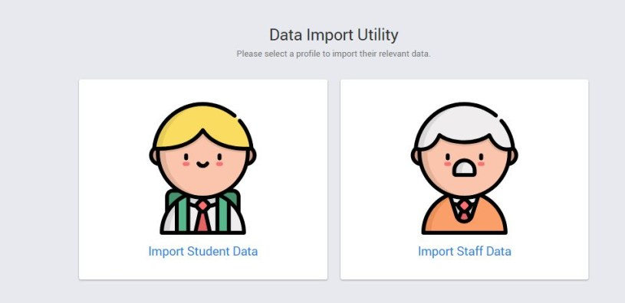
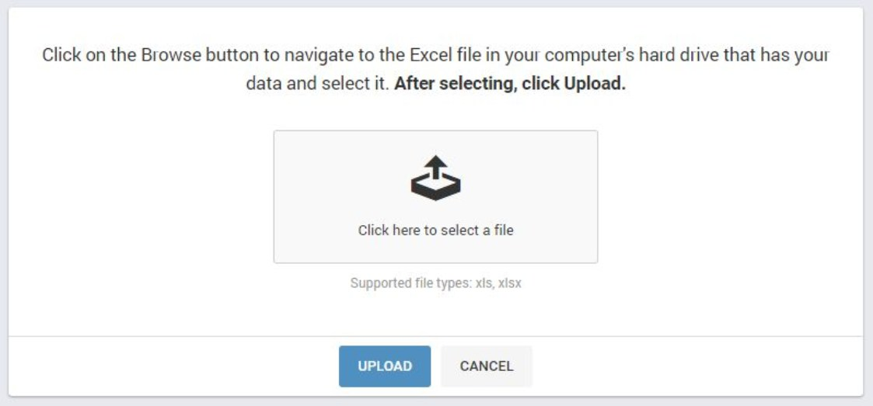
Click Import Student Data, you will get a screen asking you to navigate to the Excel sheet where the data is. Click on the select file and select the Excel sheet from your computer and click upload.

The system will read the first row of the Excel sheet which has the names of the columns and list them on the left side. On the right side will be the names of the SIS database columns that are available for mapping.

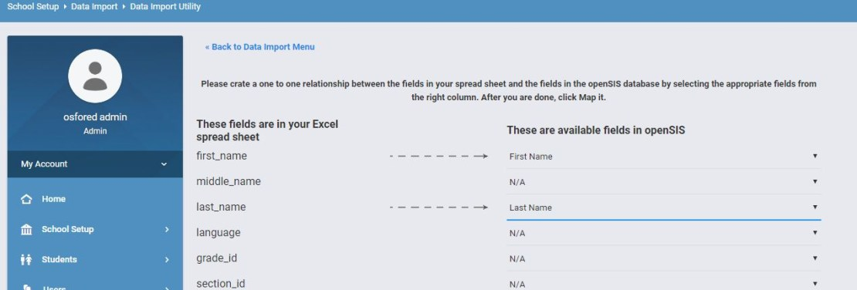
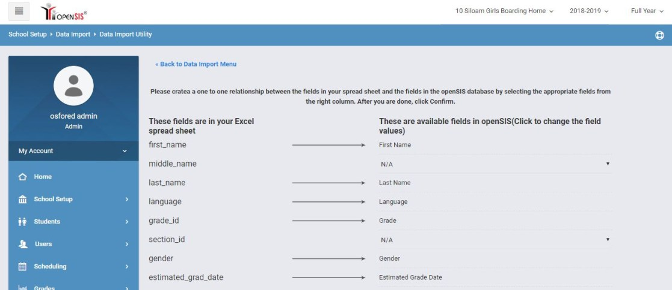
Now select first name from drop down for the first name option and last name for the last name option. You’ll see a dashed arrow will appear implicating that first name will be mapped to students first name and so on. Below is a screen shot of the same.

When you’re done hit the Map It button at the end of the screen. This will take you to a confirmation step where you can change any mapped value or assign any unassigned value. Below is screen shot of the same.

Now suppose you missed assigning section you will get a chance to do so. Below is an example of the same.

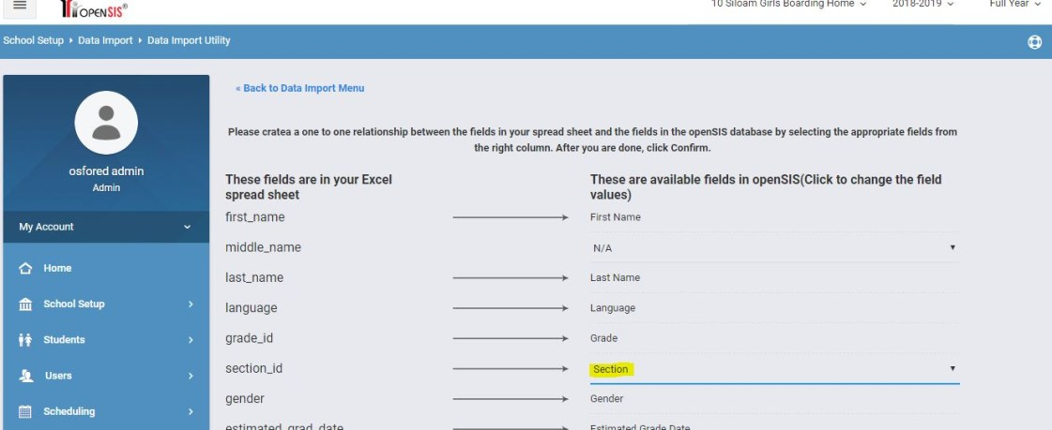
You’re almost done now just hit the confirm button at the bottom of the screen and data will get mapped. You’ll be having a question what if my Excel sheet contains 500 records and after uploading 300 records the server crashes. No worries don’t change anything in the Excel and go ahead uploading the same fields all the same mapped value. System will always ignore any duplicate records and will start from the 301st record.

Go ahead and try importing data using the tool.

